**DAY 04**

**Dataset**

Architeratural Design dataset (multi-class dataset) have been shared with ten s namely altar, apse, bell_tower, column, dome(inner), dome(outer), flying buttress, gargoyle, stained_glass, vault.

Train set : train

Test set : test

*Google Drive*

<https://drive.google.com/drive/folders/1CowMN9zfyOzgF46UsqQ-j7xs90r8NjCC?usp=drive_link>

**Convolutional Neural Network**

A convolutional neural network (CNN), is a network architecture for deep learning which learns directly from the data.

*CNN Architecture*

* VGG
* Xception
* ResNet
* InceptionV3
* InceptionResNet
* MobileNet
* DenseNet
* NasNet
* EfficientNet
* ConvNEXT

*Reference*

<https://towardsdatascience.com/top-10-pre-trained-models-for-image-embedding-every-data-scientist-should-know-88da0ef541cd>

<https://www.tensorflow.org/api_docs/python/tf/keras/applications/densenet/DenseNet169>

**MobileNet**

*Confusion Matrix*

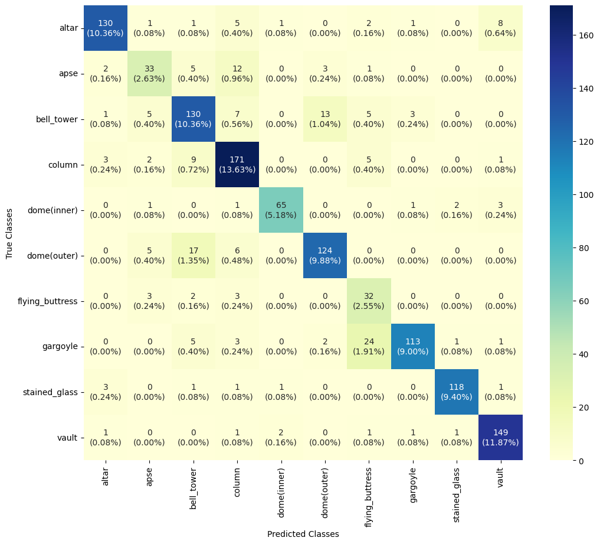

**Epoch :** 100

**Batch size :** 64

**LR :** 0.001

**Accuracy :** 0.848606

**Precision :** 0.827088

**Recall :** 0.831346

**F1 score** : 0.822737

**DenseNet**

*Confusion Matrix*

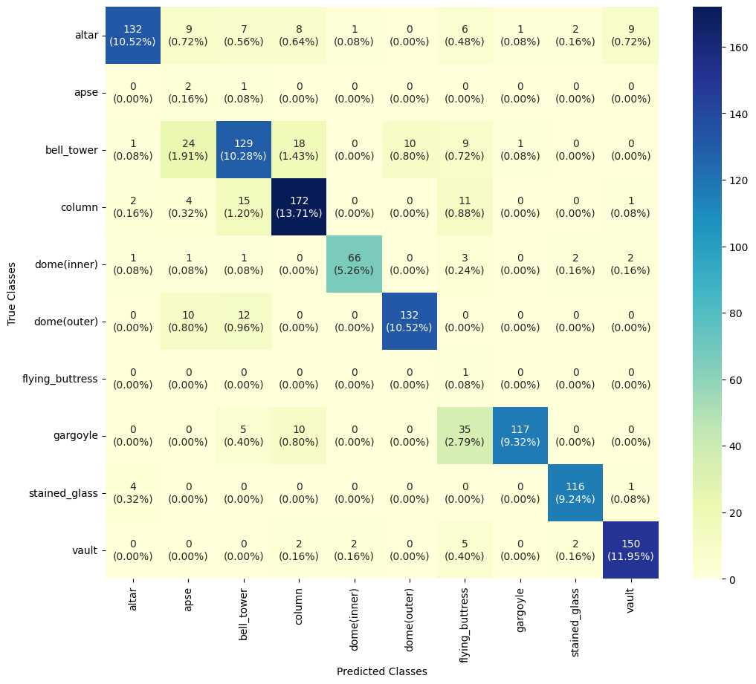

**Epoch :** 100

**Batch size :** 64

**LR :** 0.001

**Accuracy :** 0.810359

**Precision :** 0.731537

**Recall :** 0.824837

**F1 score** : 0.698444